GitHub : <https://github.com/sundershyam04/Phase3-PracticeProject4-MarksWebAPI.git>

* **Get Marks List:**

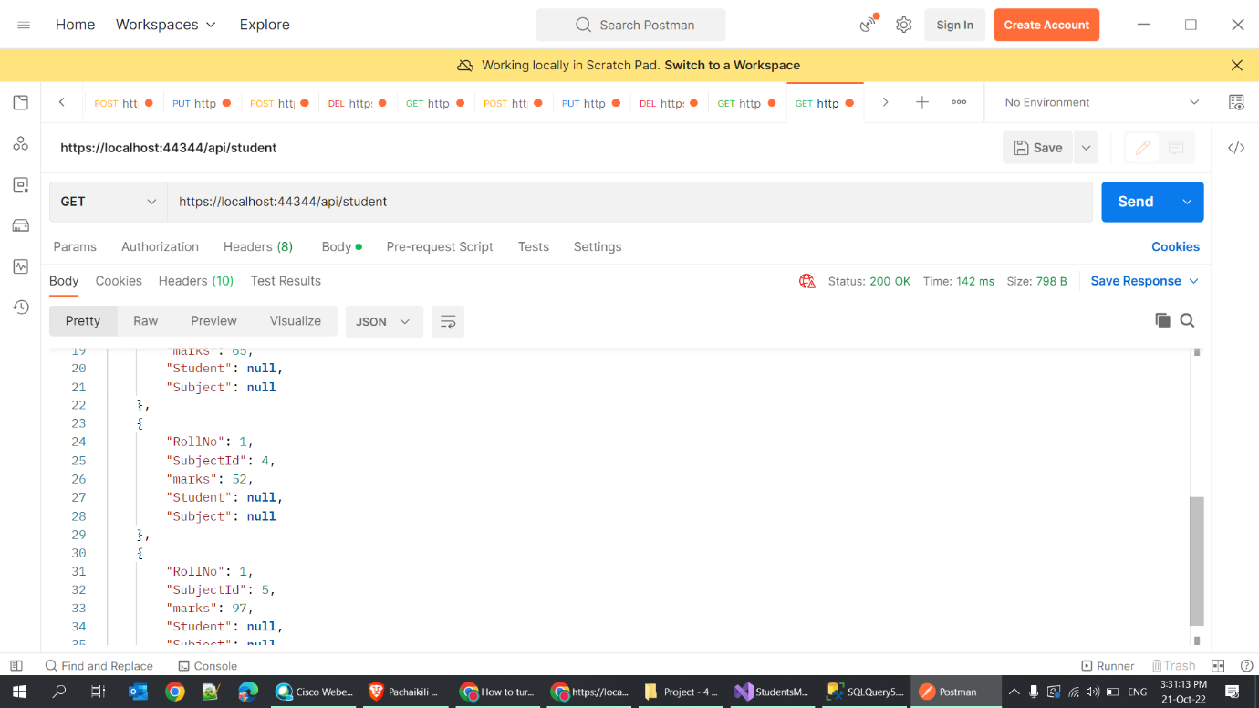

* **Add Marks:**

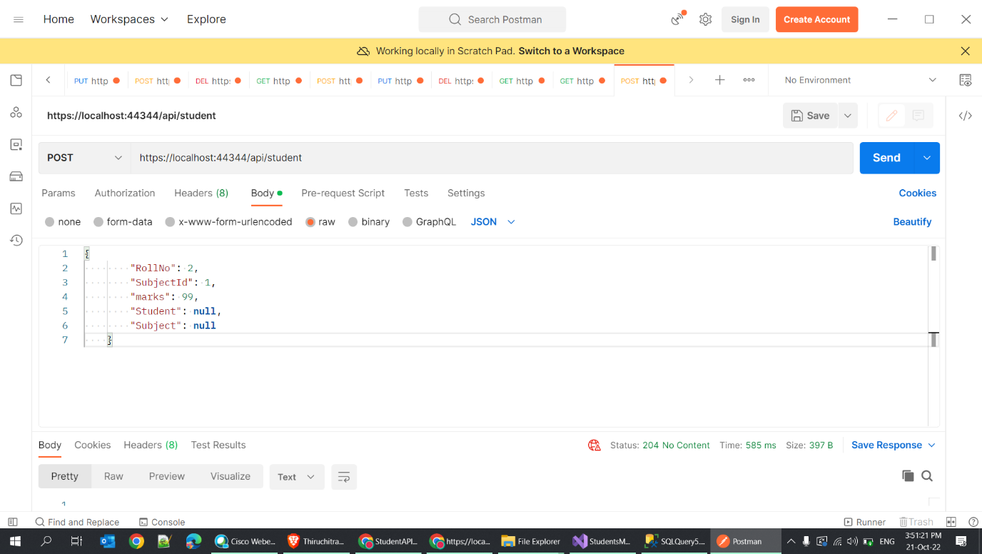

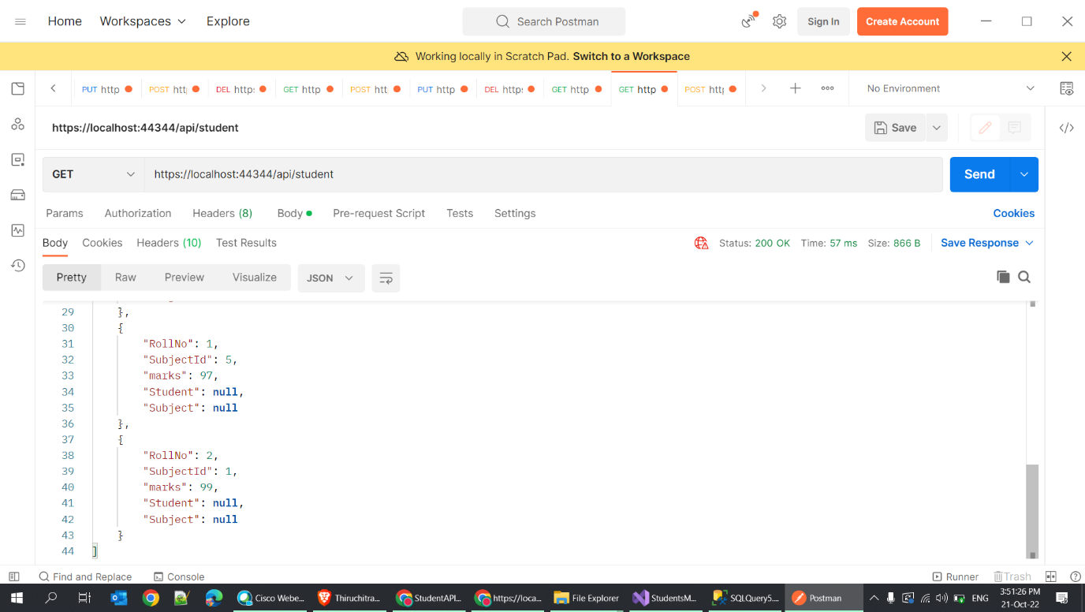.

* Marks added
* **Update Marks**

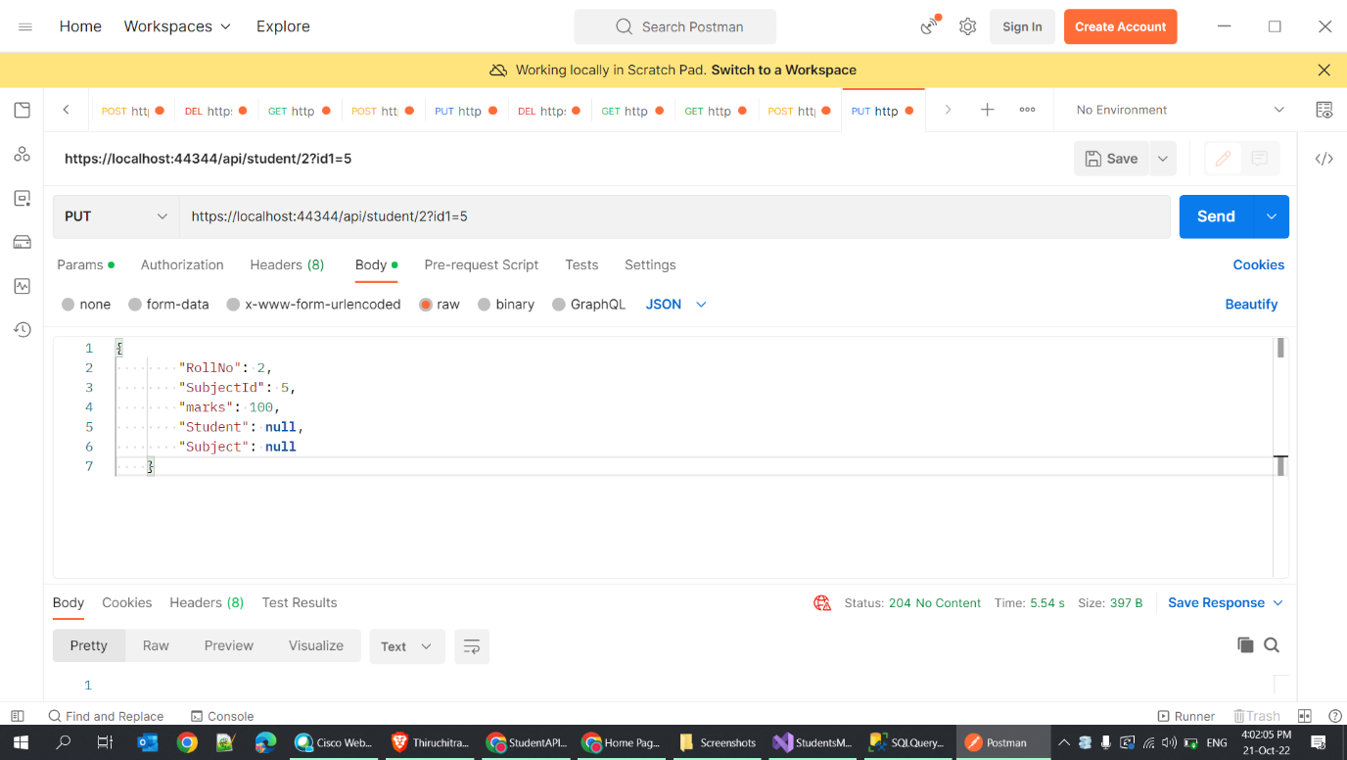

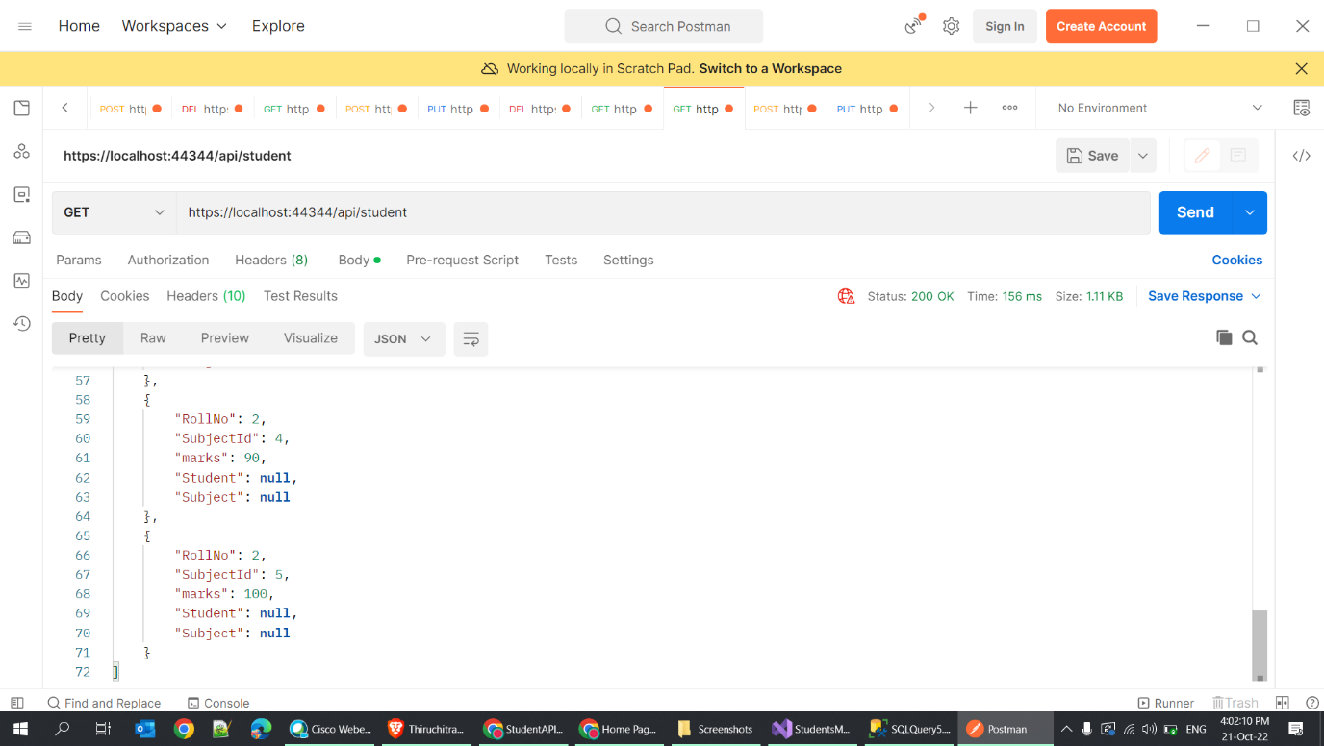

* Marks of rollno = 2 , subjectId = 5 is updated to 100.
* **Delete Marks**

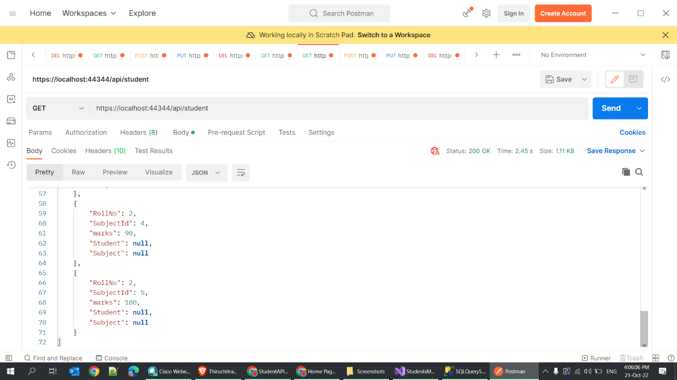

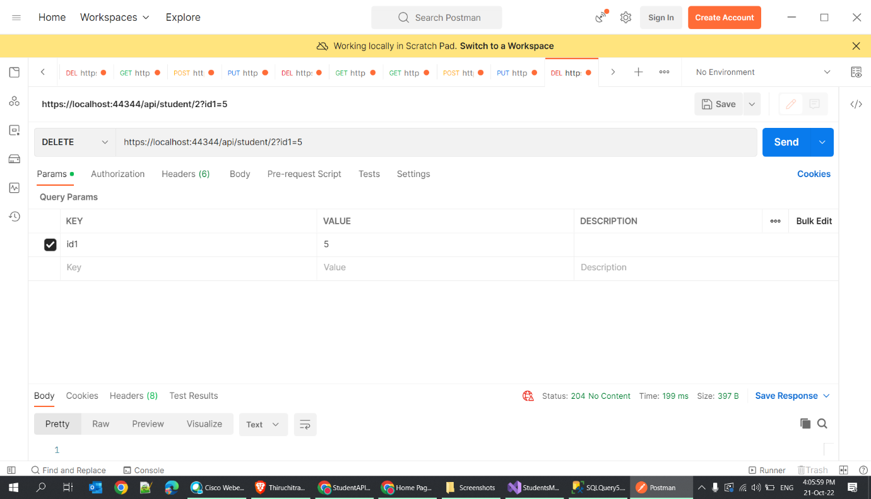

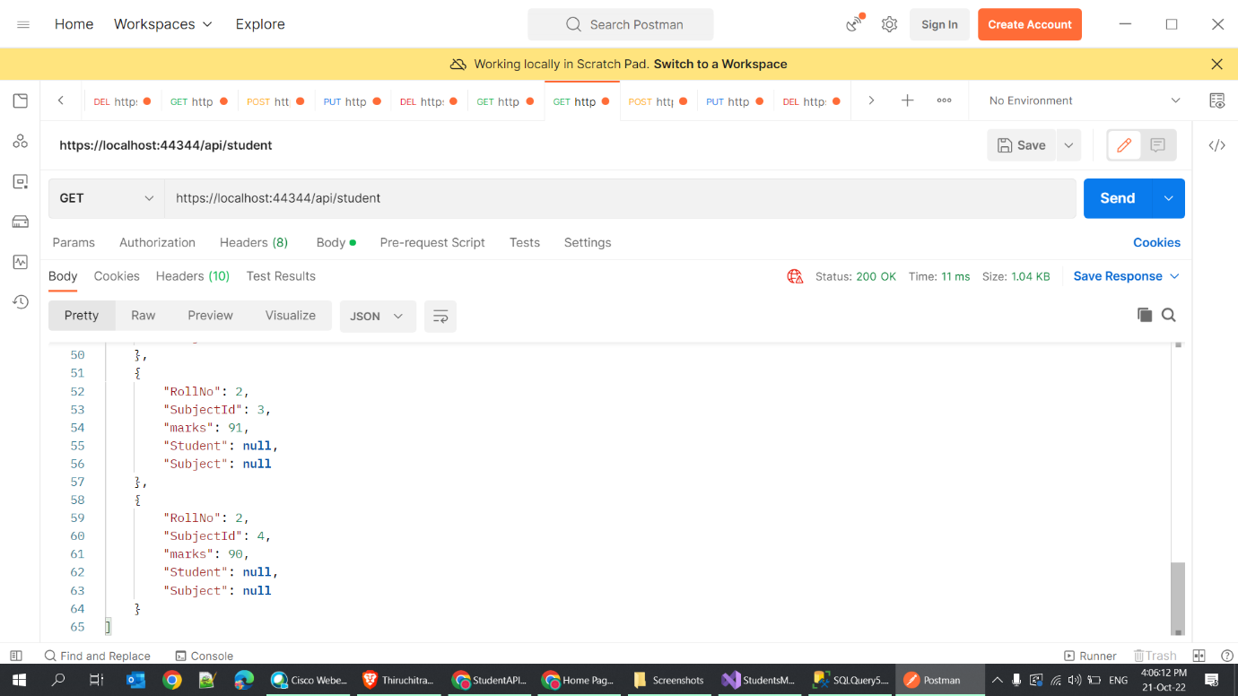

* Marks field with RollNo = 2, SubjectID =5 is deleted.